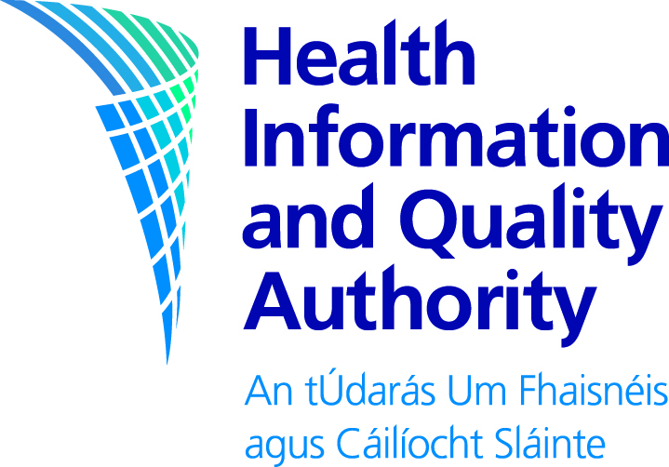

**Guidelines for the Budget Impact Analysis of Health Technologies in Ireland**

**For public consultation**

**Consultation Feedback Form**

Your feedback is very important to us. We welcome comments you would like to make.

When commenting on a specific section of a document, it would help if you can identify which element you are commenting on and the relevant page number.

**The consultation remains open until 5pm on 2 December 2024.**

**You may email a completed form to us at** [**consultation@hiqa.ie**](mailto:consultation@hiqa.ie) **. Alternatively, you can post the completed form to: HTA Directorate, Health Information and Quality Authority, George's Court, George's Lane, Dublin 7, D07 E98Y. You may also complete and submit your feedback online** [**here**](https://hiqa.qualtrics.com/jfe/form/SV_bwtgKGdzYIwENZI)**.**

**About you**

|  |  |
| --- | --- |
| **Name** |  |
| **Your or your organisation’s country** |  |
| **Today’s date** |  |
| **Would you like your name and or that of your organisation to be kept confidential and excluded from the published summary of responses?** |  |

# General Information and Questions

You may provide us with feedback on the specific questions (see questions that follow), or alternatively you may provide us with general comments.

**Part 1**

Are you replying in a personal capacity or on behalf of an institution or organisation?

|  |  |
| --- | --- |
| 🞎 Personal capacity |  |
|  |  |
| 🞎 On behalf of an institution | *Please name* |
|  |  |
| 🞎 On behalf of an organisation | *Please name* |

**Part 2**

Please provide any general or specific feedback you have on the draft BIA guidelines. Where applicable, please specify the section of the guidelines to which you are referring.

|  |
| --- |
| *Please comment* |

**Part 3**

Please outline any issues with the clarity or presentation of the report. In your response, where applicable, please specify the section to which you are referring.

|  |
| --- |
| *Please comment* |

**Thank you for taking the time to give us your views.**

After the closing date, we will assess all feedback and use it to finalise our documents. The final documents and the Statement of Outcomes (a summary of the responses) will be published on [www.hiqa.ie](../Post-Comms%20review/www.hiqa.ie).

If you wish to do so, you can request that your name and or organisation be kept confidential and excluded from the published summary of responses. Please note that we may use your details to contact you about your responses. We do not intend to send responses to each individual respondent.

Please return your form to us either by email:



[consultation@hiqa.ie](mailto:consultation@hiqa.ie)

or you can post it to:

HTA Directorate, Health Information and Quality Authority, George's Court, George's Lane, Dublin 7, D07 E98Y

or you can complete the form online at:

<https://hiqa.qualtrics.com/jfe/form/SV_bwtgKGdzYIwENZI>

If you have any questions you can contact the consultation team by emailing [consultation@hiqa.ie](mailto:consultation@hiqa.ie).

**Please return your form to us either by email or post before**

**5pm on 2 December 2024**

Please note that HIQA is subject to the Freedom of Information (FOI) Acts and the statutory Code of Practice regarding FOI.

For that reason, it would be helpful if you could explain to us if you regard the information you have provided as confidential. If we receive a request for disclosure of the information, we will take full account of your explanation, but we cannot give an assurance that confidentiality can be maintained in all circumstances.