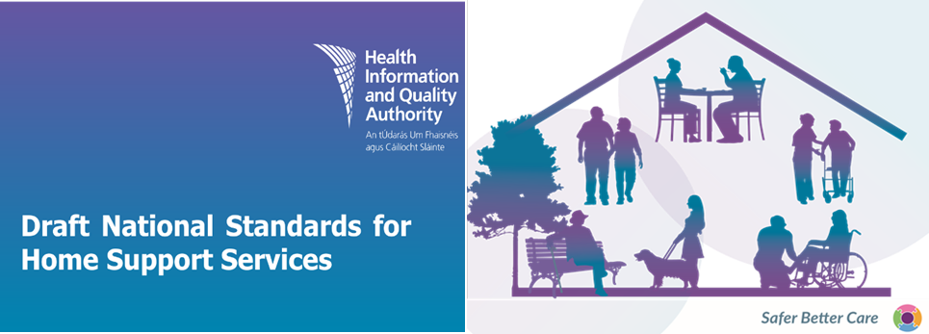

**Public consultation feedback form 04 November 2024**

The Health Information and Quality Authority (HIQA) is holding a six-week public consultation to give people an opportunity to provide feedback on the draft *National Standards for Home Support Services*. Your views are very important us, and we will carefully assess all feedback received and use it to help develop the final standards, for research purposes and to inform further reports and publications.

The standards and a stakeholder involvement report (a summary of the consultation responses) will be published on HIQA’s website once the standards have been approved.

Please note: the focus for this consultation is the content and structure of the draft standards.

We would like your feedback on each of the sections in the national standards document. There are also some general questions about the overall document. For each comment you make, it would help us if you named the section of the standards and page number of the document your comment relates to. We welcome responses to all questions, as well as any additional general comments you would like to make.

**The closing date for the public consultation is 5pm on Friday 13 December 2024.**

**Instructions for submitting feedback**

**How to provide feedback.**

* If you are commenting in a personal capacity and would like to be contacted to take part in future stakeholder engagement, there is an option to provide your name and contact details.

* If you are commenting on behalf of an organisation, please combine all feedback from your organisation into one submission form. In this case, we will request a name and contact number for a designated representative from your organisation in case we need to verify the authenticity of your feedback.
* If your feedback contains any commercially sensitive or confidential information, please highlight this at the time of submission, so it can be excluded from the summary of feedback that will be published by HIQA.
* When completing this form online, please ensure you scroll down through the webpage and complete the form in full.
* Please include the page number and section you are commenting on.
* Do not paste other tables into the boxes already provided — type directly into the box, as the box expands.
* Please spell out any abbreviations that you use.

**You can email or post a completed form to us. You can also complete and submit your feedback on** [**www.hiqa.ie**](http://www.hiqa.ie)

**Data protection and Freedom of Information**

HIQA will only collect personal information, such as the names of individuals who provided feedback or any other personal details, during this consultation, for the purposes of verifying your feedback, or where you have indicated that you would like to be contacted to partake in future stakeholder engagement. No personal information will be included in the stakeholder consultation document that will be published by HIQA. All personal information will be deleted once it is no longer needed, in line with HIQA’s record retention policy.

The feedback in your consultation form will be used to help develop the draft *National Standards for Home Support Services* and in related publications and research. Any feedback you provide will be held securely and anonymised. If included in publications, it will be in an anonymised and summative manner.

For further information on how HIQA uses personal information, please see our Privacy Notice available [here](https://www.hiqa.ie/sites/default/files/2018-05/HIQA-Privacy-Notice.pdf). If you have any concerns regarding your personal information, please contact HIQA’s Data Protection Officer on [dpo@hiqa.ie](mailto:infogovernance@hiqa.ie)

Please note that HIQA is subject to the Freedom of Information (FOI) Act and the statutory Code of Practice in relation to FOI. If we receive a request under FOI for the submissions received as part of this consultation process, we will contact you and take full account of your views on the release of these records. However, we cannot give you an assurance that confidentiality can be maintained in all circumstances due to the requirements of the FOI Act.

**I agree to take part in the public consultation**

We will carefully assess all feedback received and use it, along with other available evidence, to develop the draft national standards and related publications

The feedback in your consultation form will only be used to help develop the Draft National Standards for Homecare and support services and in related publications. Any feedback you provide will be held securely and anonymised. If included in publications, it will be in an anonymised and summative manner.

Personal information will not be published and will be destroyed from our records within xx date, subject to legal requirements under Freedom of Information (FOI) legislation.

(FOI) legislation.”

1. **About you**

**1.1 Are you providing feedback as:**

an individual

on behalf of an organisation

**1.2. If answer is “an individual”**

Which of the following best represents you?

a person who has used or is currently using home support services

a family member of a person who has used or is currently using home support services

a home support worker

a healthcare professional involved in hospital or community services

a member of the public

other (Please specify)

If selected “**other**” above, please give details here:

**1.3. If answer is “on behalf of an organisation”, please give the name of the organisation:**

**For verification purposes, please provide your name and your role in the above organisation and your contact details:**

**1.4. If you would like to be contacted to take part in future stakeholder engagement about the national home support standards, please provide your name and contact details below:**

|  |  |
| --- | --- |
| **Name:** |  |
| **Phone:** |  |
| **Email:** |  |

**2. Your feedback on the draft *National Standards for Home Support Services***

In this section, we would like to find out what you think of the content of the draft national standards. This section focuses on the four principles, standard statements and features in the draft standards. The questions in this section are not intended in any way to limit your feedback, and other comments relating to the draft national standards are welcome.

**The draft standards are underpinned by four principles:**

* A Human Rights-based Approach
* Safety and Wellbeing
* Responsiveness
* Accountability.

Taken together, the principles, standard statements, and the features of a good service, provide a common language to describe what high-quality, safe, consistent, person-centred home support services should look like.

**Please consider the following questions as part of your review of the draft standards:**

* Do you think all important areas have been covered in each standard statement or are there any areas that should be included or excluded? Please provide the standard number you are commenting on in your feedback.
* Do you have any comments or feedback on any of the features? Please include the feature number you are commenting on in your feedback.

**2.1. Please provide your feedback on the standard statements and features set out under Principle 1: A Human Rights-based Approach**

**2.2. Please provide your feedback on the standard statements and features set out under Principle 2: Safety and Wellbeing**

**2.3. Please provide your feedback on the standard statements and features set out under Principle 3: Responsiveness**

**2.4. Please provide your feedback on the standard statements and features set out under Principle 4: Accountability**

**3. General feedback**

**3.1 Is the language used in the draft standards clear, easy to follow and easy to understand?**

Yes  No  Unsure

Any additional comments:

**3.2** **Is the content and structure of the draft standards clear, easy to follow and easy to understand?**

Yes  No  Unsure

Any additional comments:

**3.3 Are there any other comments or suggestions on the draft standards that you would like to make?** For example comments on areas covered in the introductory section, scope, interaction with other standards and regulations or key terms used.

**3.4** **Having read the draft standards, do you have a better understanding of how services can deliver high-quality, safe, consistent and coordinated care and support to people using home support services?**

Yes  No  Unsure

Any additional comments:

**3.5** **If you work in a home support service, having read the draft standards, do you intend to make changes to your work practices?**

Yes  No  Unsure

Please provide additional detail:

**3.6** **Do you think there will be the challenges implementing these standards in home support services?** **If so, please describe:**

**3.7** **What do you think is working well in home support services at the moment that would help to implement these standards?**

**3.8** **What additional tools, guidance or educational materials do you think are needed to support the implementation of these standards in the service you use or work in?** Please be as specific as you can (for example what type of guidance or educational materials and for what setting or group)

**Thank you for taking the time to give us your views on the draft *National Standards for Home Support Services***

Please return your form to us by email or post.

You can **download** a consultation feedback form at [www.hiqa.ie](http://www.hiqa.ie)

Then **email** the completed form to [standards@hiqa.ie](mailto:standards@hiqa.ie)

**OR**

Print the consultation feedback form and **post** the completed form to:

Health Information and Quality Authority

Dublin Regional Office

George’s Court

George’s Lane

Smithfield

Dublin 7

D07 E98Y.

If you have any questions on this document, you can contact the HIQA Standards Team by

Phoning: **(01) 814 7400**

**OR**

Emailing: [**standards@hiqa.ie**](mailto:standards@hiqa.ie)

**Please ensure that you return your form either by email or post by Friday 13 December 2024**