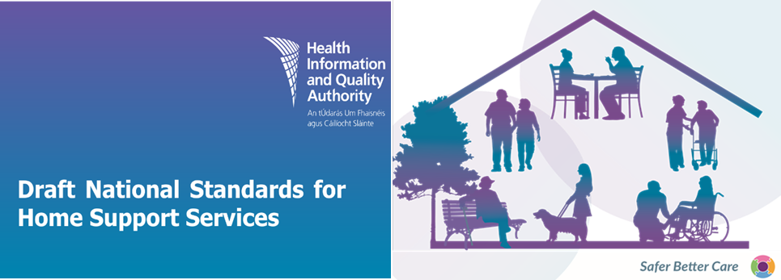

**Public consultation survey – Easy-to-read version**

**What is this consultation about?**

HIQA wants to hear what you think about the draft *National Standards for Home Support Services*. This is called a consultation.

We want to know what you think about the standards.

You can also tell us about any changes you would like to make to them.

**How do I take part?**

You can take part by completing this survey. A survey is a short list of questions about your opinion.

This survey has 3 sections:

* **Section 1** asks about you.
* **Section 2** asks about what is in the draft standards.
* **Section 3** asks general questions.

When you finish responding to the questions you can:



Send the survey by **email** to [standards@hiqa.ie](mailto:standards@hiqa.ie)

**OR**



Print the survey and **post** to:

Health Information and Quality Authority. Dublin Regional Office. George’s Court

George’s Lane

Smithfield

Dublin 7. D07 E98Y.



If you want a copy of the survey you can find it on our website [www.hiqa.ie](http://www.hiqa.ie) and then print it out.

**OR**



You can email us at [standards@hiqa.ie](mailto:standards@hiqa.ie) to ask for a copy.

**When should I send my views?**

You should respond to this survey by 5pm on Friday 13 December 2024.

**13 December**

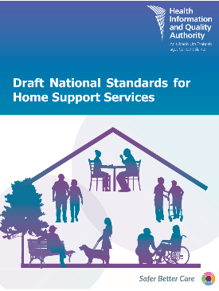**What will happen after I send the survey?**HIQA will look at what people say about the standards and decide if we need to make changes.

HIQA will also write a report and research studies, using what people tell us.

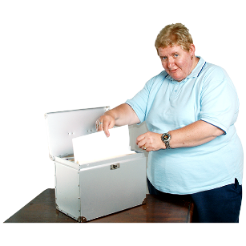

**Privacy Notice**

* By answering this survey, you are agreeing to take part in the public consultation.
* We will not put anyone’s name in the standards, reports or research studies.
* HIQA is subject to the Freedom of Information (FOI) Act and the Code of Practice in relation to FOI.
* All information you provide will be treated securely.

**Section 1. About you**

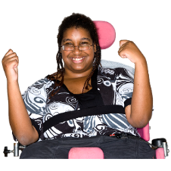**Question 1a.** Who are you answering the questions for?

Yourself



A group or organisation

**Question 1b.** If you said **Yourself**

Have you used home support services **in the past**?



Are you **currently** using home support services?

Other

If you said **other**, please explain here:

**Question 1c.** If you said **A group or organisation**



What is the name of the group or organisation you are answering this survey for?

What do you do in the above organisation?



**Question 1d.** If you want to be contacted **for future discussions** about the National Standards for Home Support Services, please provide your name and contact details below.

|  |
| --- |
| **Name:** |
| **Phone:** |
| **Email:** |

**Section 2. Your views on the content of the draft standards**

**Standards under the Human Rights principle**

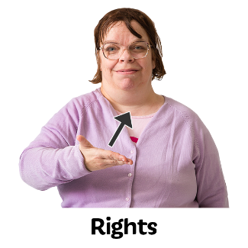

**Question 2a.** What do you think about ideas for the **standards under the human rights principle?**

**Question 2b.** Should we include or remove any ideas from this principle?



**Question 2c.** Is there anything else you would like to tell us?

**Standards under the Safety and Wellbeing principle**



**Question 3a.** What do you think about ideas for the **standards under the safety and wellbeing principle?**

**Question 3b.** Should we include or remove any ideas from this principle?

**Question 3c.** Is there anything else you would like to tell us?

**Standards under the Responsiveness (Good and Timely support) principle**

**Question 4a.** What do you think about ideas for the **standards under the responsiveness (good and timely support) principle?**

**Question 4b.** Should we include or remove any ideas from this principle?

**Question 4c.** Is there anything else you would like to tell us?

**Standards under the Accountability (well-managed service) principle**

**Question 5a.** What do you think about ideas for the **standards under the accountability (well-managed service) principle?**

**Question 5b.** Should we include or remove any ideas from this principle?

**Question 5c.** Is there anything else you would like to tell us?

**Section 3. General questions**

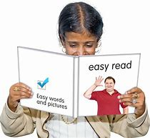**Question 6.** Do you think the**words and pictures** in these standards are:

Easy to understand?

**OR**

Difficult to understand?

If you think these standards are **difficult to understand**, please tell us how we can make it easy to understand.

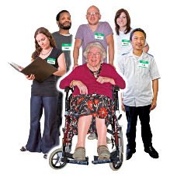**Question 7.** Do you think these standards will help to improve the home support services in Ireland?

Yes  No  Not sure

If you said **No or Not sure**, please tell us why.

**Question 8.** We want to make sure that home support services will use these standards.

What do you think would help home support services to use these standards?

**Question 9.** Are there any other ways that we could improve these standards?



**Thank you** for taking the time to give us your views on the draft *National Standards for Home Support Services*.